LEX Program to Count Alphabetic Characters and Digits
Aim :
To write a LEX program to count the number of alphabetic characters and digits in a given input file.

Pseudocode :
BEGIN
Open input.txt
If file cannot be opened
Display error message
STOP
End if
Initialize alphabets = 0
Initialize digits = 0
Read the input file
Count alphabetic characters
Count digits
Display both counts
Close the file
END

Code :

%{
#include <stdio.h>
int alphabets = 0;
int digits = 0;
%}
%%
[A-Za-z] { alphabets++; }
[0-9] { digits++; }
.|\n ;
%%
int yywrap(void)
{
return 1;
}
int main(void)
{
FILE *fp = fopen("input.txt", "r");
if (fp == NULL)
{
printf("Error opening file\n");
return 1;
}
yyin = fp;
yylex();
printf("Alphabetic characters: %d\n", alphabets);
printf("Digits: %d\n", digits);
fclose(fp);
return 0;
}

Output :
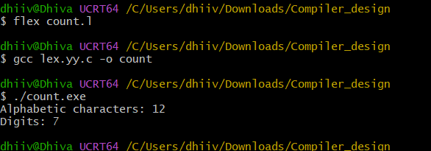

Result :

Thus, the LEX program was successfully executed to count the alphabetic characters and digits in the input file.

